⚙️ How to Set Up EmailJS (One-Time Setup)

🔗 Go to: https://www.emailjs.com

Step-by-Step:

1. Sign Up or Log In
2. Click "Email Services" → Add New Service
3. Choose Gmail, Outlook, or any SMTP provider

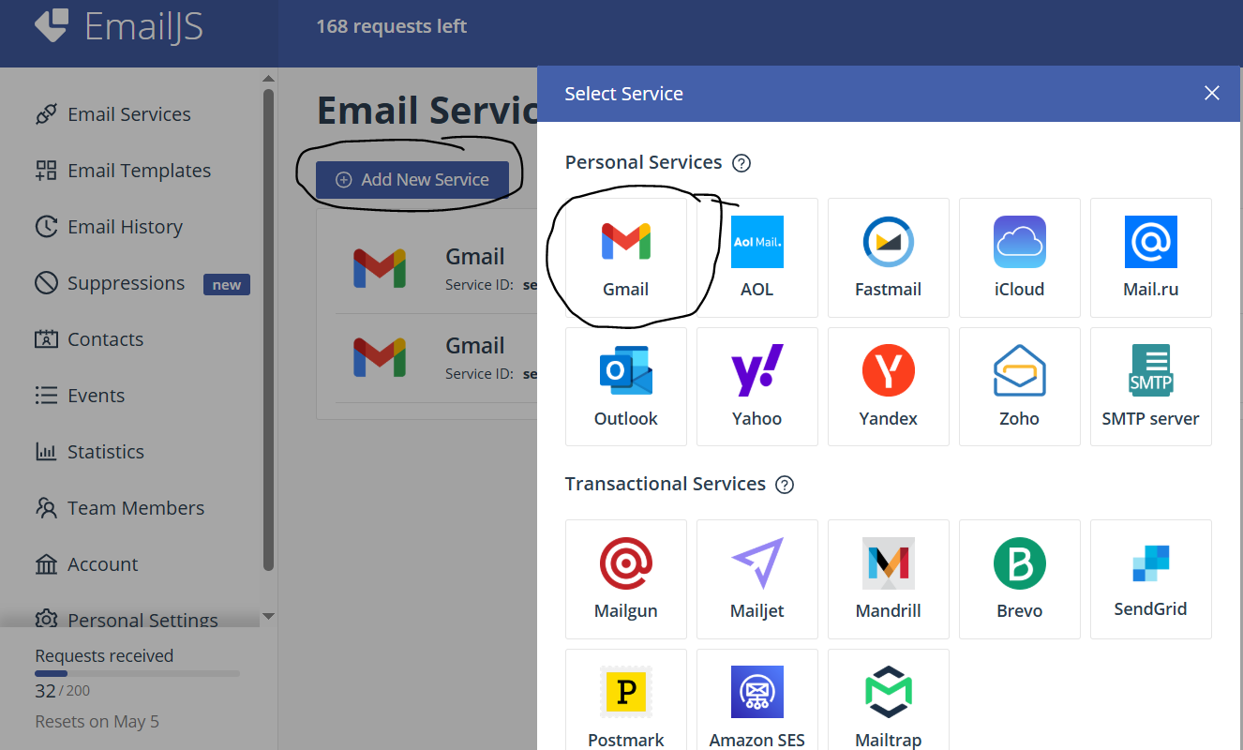

1. Name it something like subscription_service
2. Go to Email Templates: Click Create New Template. Add these variables:

* to_email
* plan_name
* plan_price

1. Use a simple message like:

Thank you for subscribing!

Plan: {{plan_name}}

Price: {{plan_price}}

1. Go to Account → API Keys
2. Copy the Public Key (YOUR_PUBLIC_KEY)
3. Copy your Service ID and Template ID
4. Replace these in the script:

**emailjs.init("YOUR_PUBLIC_KEY");**

**emailjs.send("YOUR_SERVICE_ID", "YOUR_TEMPLATE_ID", params)**